Tutorial 6

Chapter 6

- Discuss the main outputs of Requirements Quality Assurance stage to your team.
Main outputs of Requirements Quality Assurance stage:
- Consolidated RD
- Acceptance test data, prototype
- Development plan
- Project contract

- With the aid of a diagram, explain the FOUR (4) activities that involved in Requirements Inspection process to your team members.
Activities involved in Requirement Inspection:
- Inspection planning
- Individual Reviewing
- Defect Evaluation
- Requirement document consolidation
(Chapter 6 slide 9)
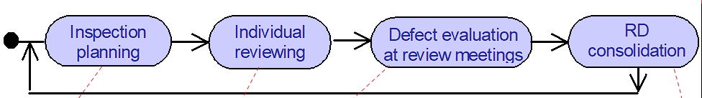
(Students are required to briefly explain each point – refer to lecture note)

- Discuss any FIVE (5) items that you would consider to be included in the defect-driven checklist for RD.
Answer may vary. Some possible items in the checklist can be:
(Omissions?)
- Is this precisely defined somewhere?
- Is there any hidden assumption required for this?
- Is the rationale for this made explicit somewhere?
(Contractions?)
- Is this consistent with stated objectives or constraints?
(Ambiguities)
- Can this be interpreted differently?
- Any other statement using this term with a different meaning?
(Unmeasurability?)
- Is there a fit criterion for this quality requirement?
- Is this stated in a way discriminating from alternative options?
(Noises?)
- Is this relevant to system objectives or constraints?
- Does the negation of this make any sense?
- Any other statement using this under different terms?
(Overspeification?)
- Does this entail/mean premature design choices – any sensible alternative?
(Unfeasibility?)
- Is this implementable within reasonable time/budget?
(Any above 4 points or any acceptable points. Students should explain their answers)

Noise: Presence in the text of an element that fails to carry information relevant to any feature of the problem Variants include
- redundancy: in which old information is repeated, but using different terms/language, thereby giving the impression that something new is being introduced, and
- remorse: in which the meaning of a term defined earlier is qualified, as though the author was sorry for the original definition.

- As your project team is going to adopt diagrammatic approach on requirements documentation, suggest and discuss ONE (1) inter-diagrams and ONE (1) intra-diagram check that you would include in your requirements checklist.
ONE inter-diagrams and ONE intra-diagram checks:
Answers vary from student to student. Some possible points can be:

Inter-diagram checks:
- Any input (output) of this DFD operation not declared in ER diagram?
- Is this event trace in ET diagram covered by a path in SM diagram?
- Every data in a flow or repository of a DFD diagram must be declared as entity, attribute, or relationship in an ER diagram

Intra-diagrams checks:
- Any output flowing out this DFD operation not flowing out and downstream suboperation in the DFD refining this operation?
- Any relationship in ER diagram with inadequate multiplicities?

(or any acceptable points with elaboration)

- Explain the differences of Mock-up Prototype and Proof-of-Concept Prototype.
Refer to lecture note/ text book

- Use relevant examples, discuss the differentiate Model Validation from Model Verification.
Refer to lecture note/ text book

- Suggest TWO(2) guidelines for defining Acceptance Criteria of Acceptance Testing.
Refer to lecture note/ text book

